Solutions Projects and Web Forms

Solutions and Projects in Visual Studio 2
Solutions and Projects 4
Creating the Solution 4
Creating the Presentation Layers 6
Creating the Staff Facing Back Office Project 7
Creating the Customer Facing Web Project 10
Creating the Default Page 14
Creating the Controls 17
Modifying the Form 21
Running the Program 22
Adding Control Objects to a Form 22
Setting the Properties for Controls 27
Adding a Second Form for Delete 29
Adding Code – Event Driven Programming 30

Solutions Projects and Web Forms
One of the issues with this module we need to think about is how the Skeleton system is structured.
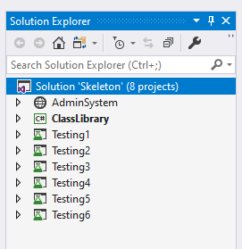
For a large part of this module we will be working extensively with Git Hub and there is a potential problem that arises here.
When working with Git Hub there is a huge potential for conflicts to arise as you merge your code to the main branch.
Clearly this is unavoidable due to the nature of working collaboratively however there is quite a high degree of skill and coding knowledge required to merge code conflicts correctly.
The skeleton has been prebuilt for you in such a way that it should help to reduce (not eliminate) conflicts as you merge your code.
This is fine for making Git Hub a bit easier to use but not much help when it comes to understanding how to build a solution containing projects from scratch.
The purpose of this lecture is to run through the background of how to create a simple solution with a project in Visual Studio along with some guidance on how to set up controls on the presentation layer.
We are going to create a presentation layer that supports the following tasks...

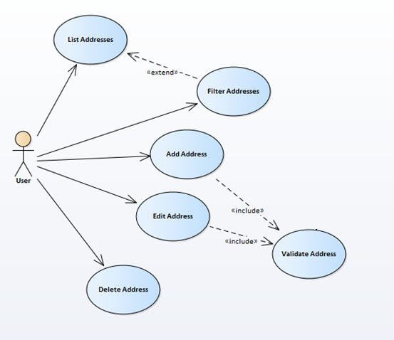

Solutions and Projects in Visual Studio
Visual Studio allows us to create projects and solutions.
A project may be a web site, a desktop application, an application based in the cloud, a mobile phone app, class library etc.
In Visual Studio we have the option of adding new or existing projects to a solution.
A solution is a master container that allows us to work on multiple projects at the same time also to create a single class library and link that class library to the projects in the solution.
Looking at this in Visual Studio we might see the following…
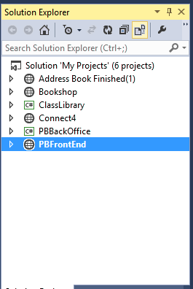
Solution
Projects
In this solution we have created six projects
- Address Book Finished
- Bookshop
- Class Library – the middle layer of the three layers shared between all of the projects
- Connect4 – a connect 4 game written in Visual Basic. (This set up allows us to mix up our languages a bit!)
- PBBackOffice – A C# Windows desktop application which would be used to maintain the project bank data
- PBFrontEnd – a C# ASP.NET web site which will be the front end for the project bank application

If we look at this from the point of view of the three layered architecture we would see the following structure (concentrating on the projects PBBackOffice and PBFrontEnd)…

PBFrontEnd
(Interface)
Data Layer
Database
Middle Layer
Business Logic
(Classes)
PBBackOffice
(Interface)

What we have here are two projects defining separate presentation layers sharing a common middle layer. Sharing a common middle layer means that both projects ultimately share a common data layer.

Solutions and Projects
Visual Studio allows us to create both solutions and projects.
A project is typically an application of some sort, for example, a desktop application, a web site or a class library (to name a few).
A solution is a container that allows us to work on multiple projects at the same time.
Start Visual Studio and you should see the main screen for the program.
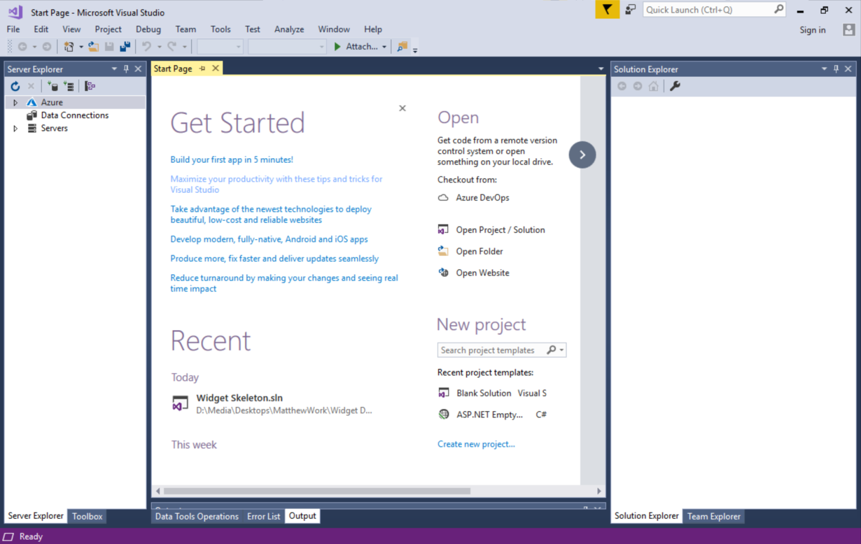

Creating the Solution
To create the solution that will allow us to manage the different projects we plan to create do the following.
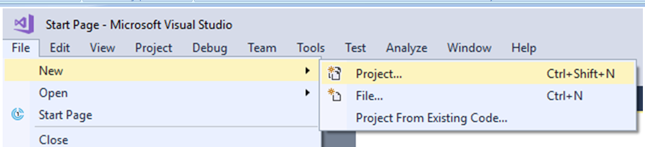
Select File – New – Project
(A solution is technically a type of project in Visual Studio!)
Under “Other Project Types” select “Visual Studio Solutions”.
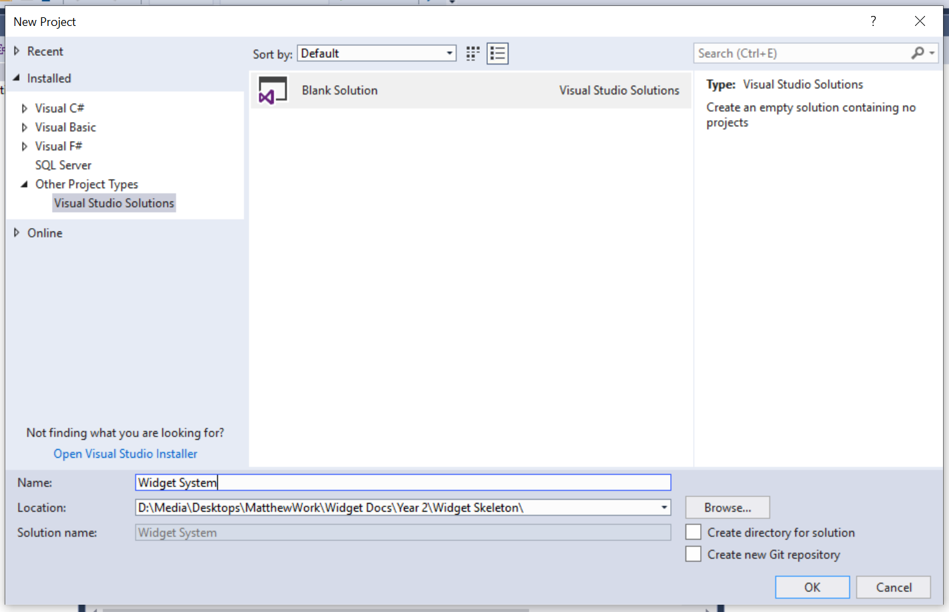
Give the solution a suitable name in my case “Widget System” and decide on a suitable path for the solution. (In my case I have already made the folder I want so I didn’t want Visual Studio to create the folder for me. In that case I un-ticked the box to stop this happening)
Press OK and you should see something like this in the solution explorer…
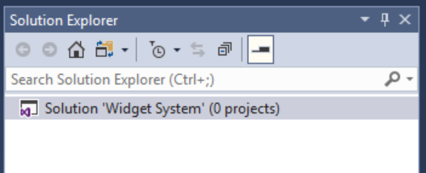
Notice that we didn’t need to specify a language for the solution.
The nice thing about creating solutions in Visual Studio is that the projects we add to it may be in any language supported by Visual Studio.
There are many different combinations allowed for by this configuration.

Creating the Presentation Layers
As you will hopefully discover one of the nice things about this configuration is that we may create multiple interfaces for our system all sharing the same class library.
Some examples of different interfaces might be...
- A customer facing web site
- A staff facing admin system
- A mobile app
- Other system-based admin processes
We will create a few examples here to give you a sense of what is possible.

Creating the Staff Facing Back Office Project
For the first example we will create a staff facing admin system.
This will not be intended for customers and in this case will not be a web application but rather a Windows desktop application.
To do this we will need to add a new project to the existing solution.
Right click on the solution in Visual Studio and select Add – New Project…
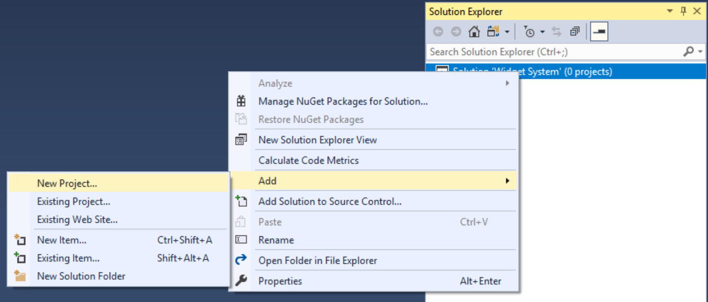
Select the following options for the new project…
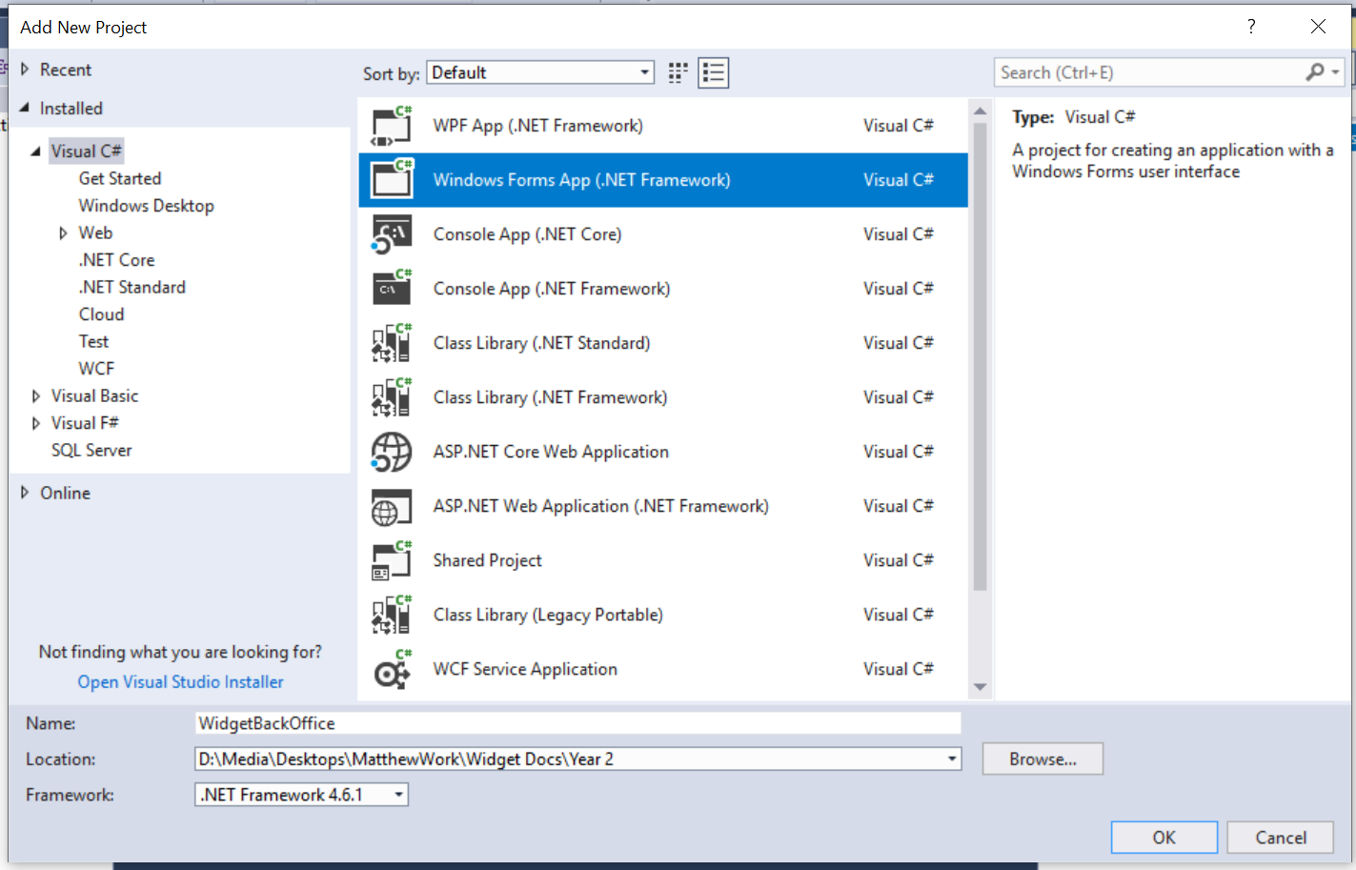
Make sure that the language is C#, the name of the project is WidgetBackOffice and the path points to the folder for your solution.
Press OK and you should see the following in the solution explorer…
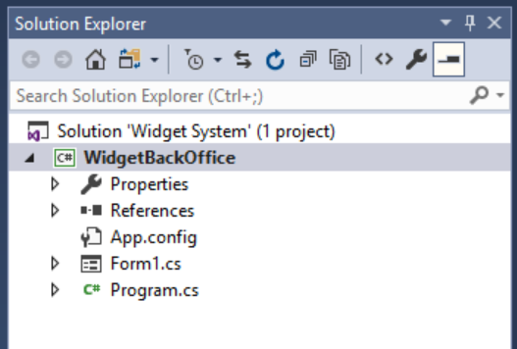
Notice also that Visual Studio has created a default form.
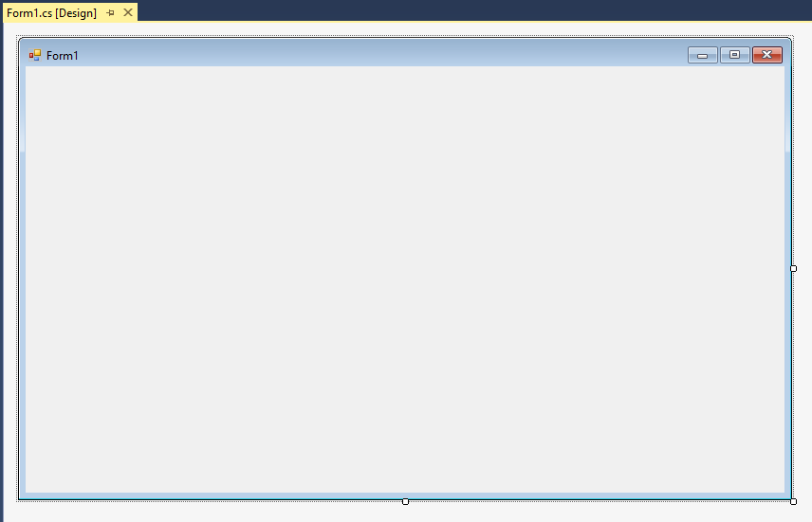

Run the solution and see what happens, you should see the default form of the new desktop application...
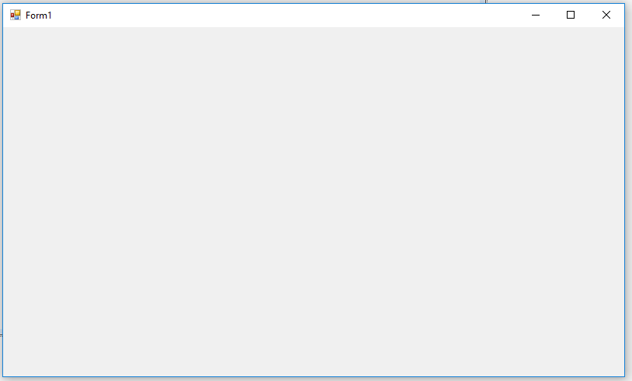
Close the program and go back to Visual Studio.

Creating the Customer Facing Web Project
Having created the back office for the application we need to set up the public facing web site.
Again, right click on the solution and select Add - New Project…
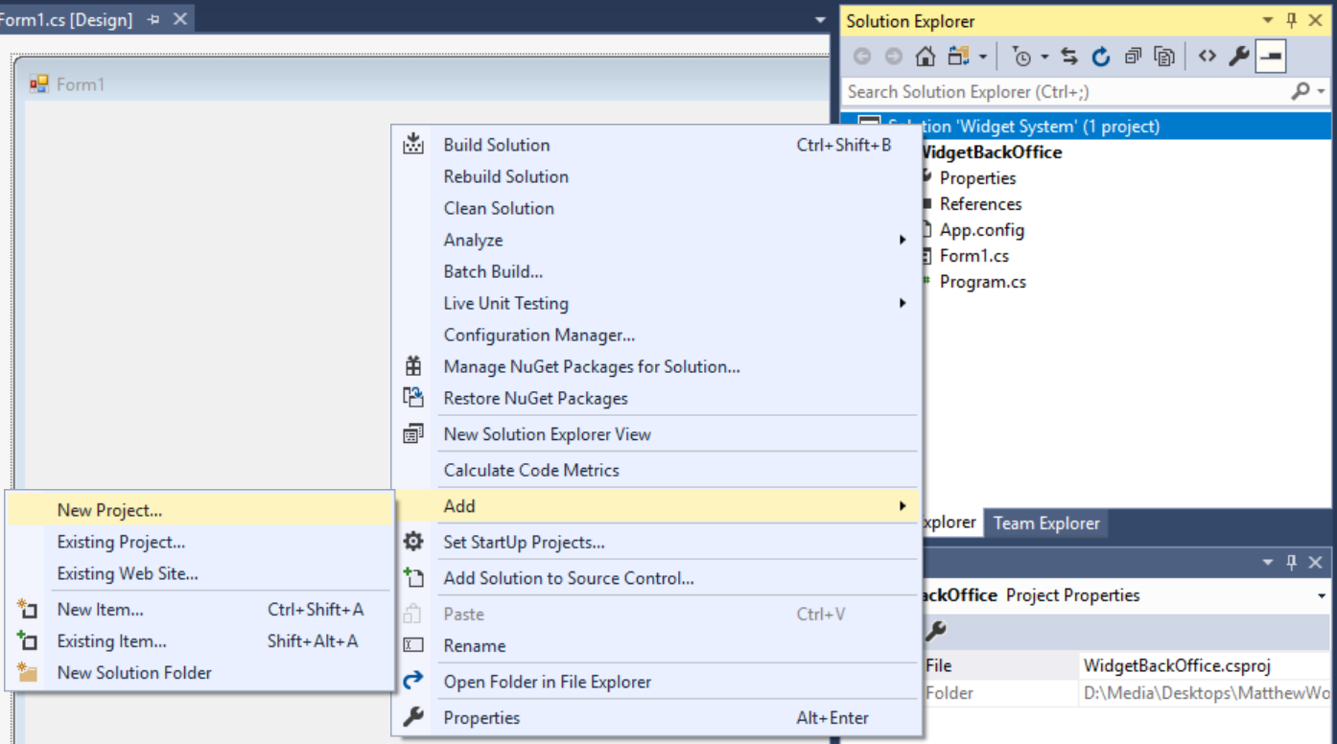
Set up the new web site like so…
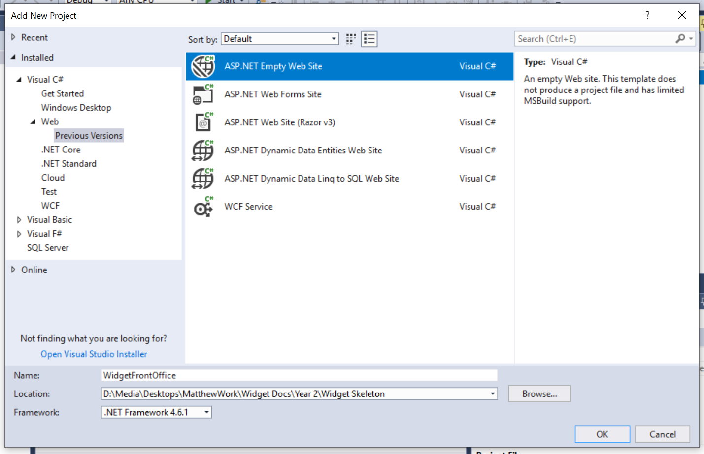
Make sure that the language is C# and that you are creating the web site (WidgetFrontOffice) inside your solution folder.
Press OK and you should now see the project in your solution alongside the first project...
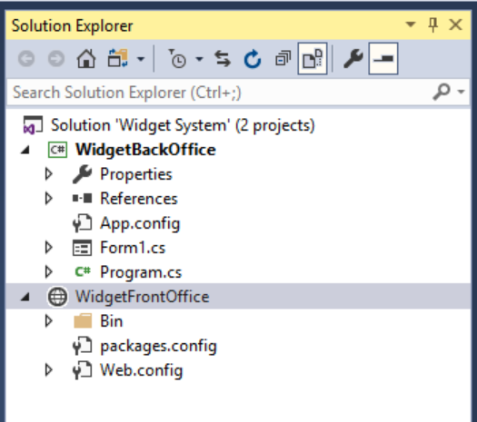

Run the program and see what happens, you should see the main page for the first project displayed still...
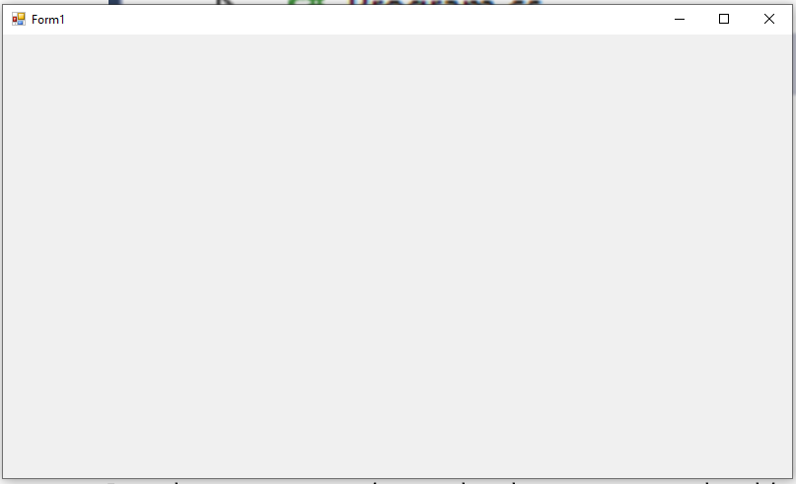
Why?
Given that we have two projects we need to tell Visual Studio which project it is supposed to run at start up.
Stop the program and right click on the new web site...
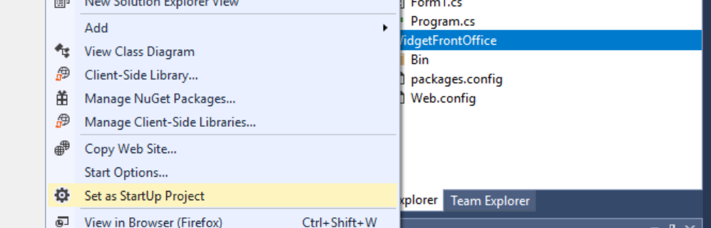
“Select set as StartUp Project”
Now run the program, what happens?
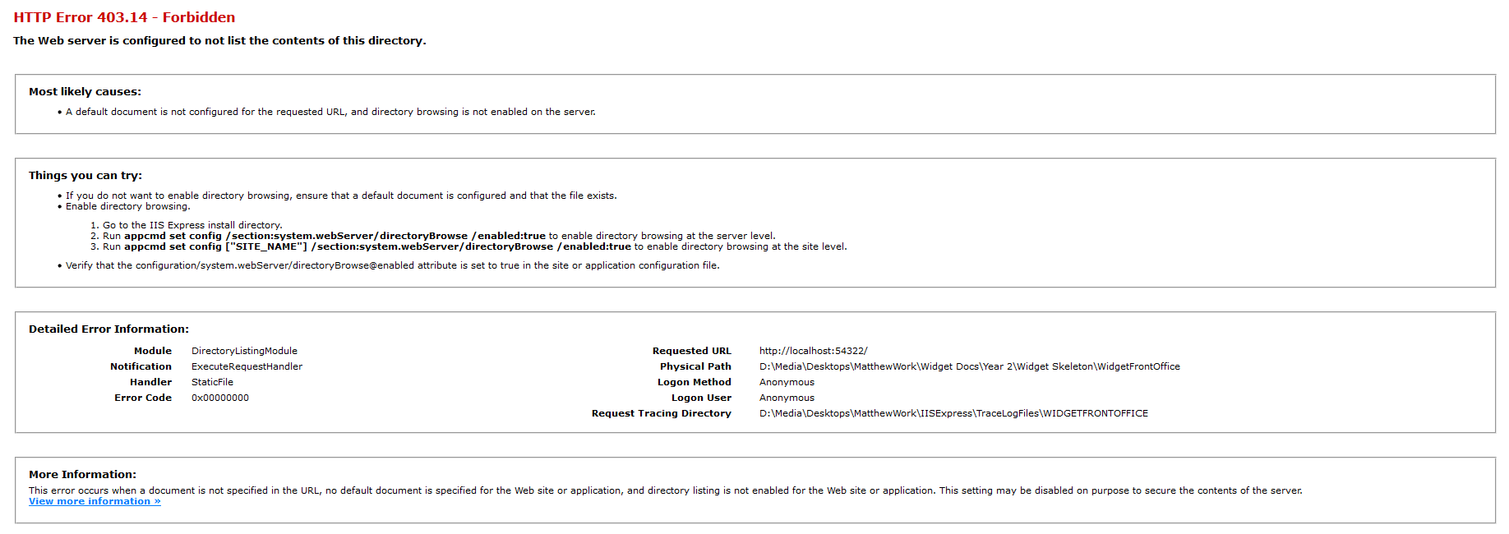
Now what is the problem?
Unlike a Windows desktop application, the web site configuration we chose does not automatically create a default page for the site.

Creating the Default Page
Right click on the website and select ADD – Add New Item...
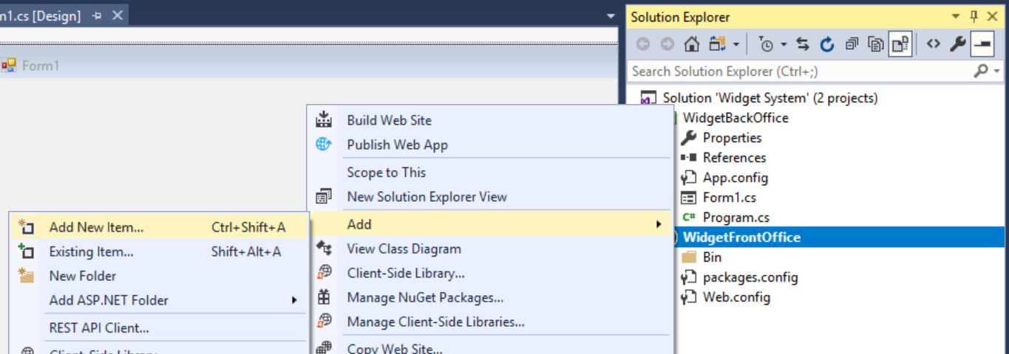
In the following screen create the default web form Default.aspx...
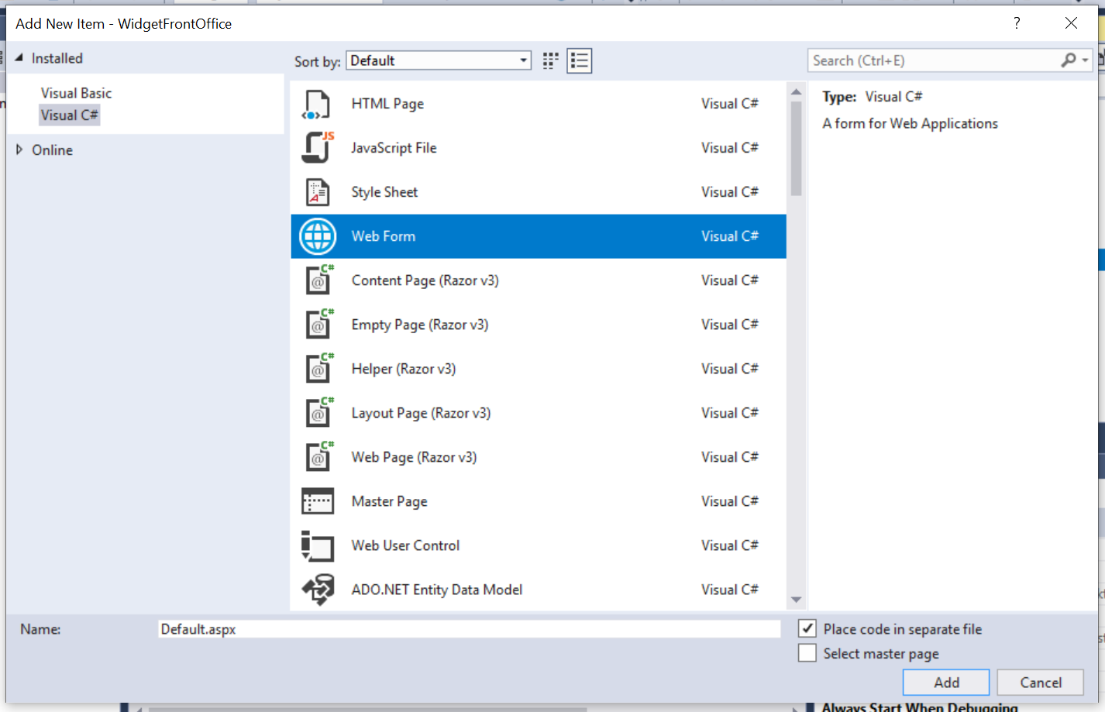
(Make sure you set the language to C#)
Press OK and you should see the new page in the web site...
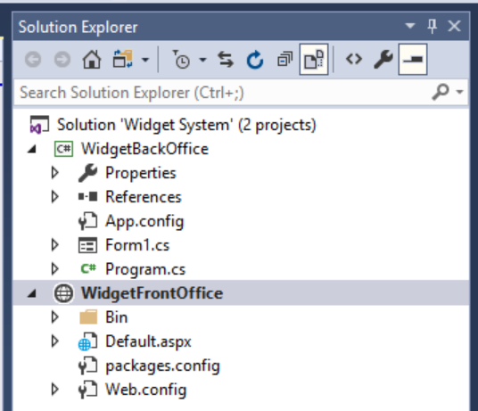
Run the program and you should find that the web site now has a (blank) start page.
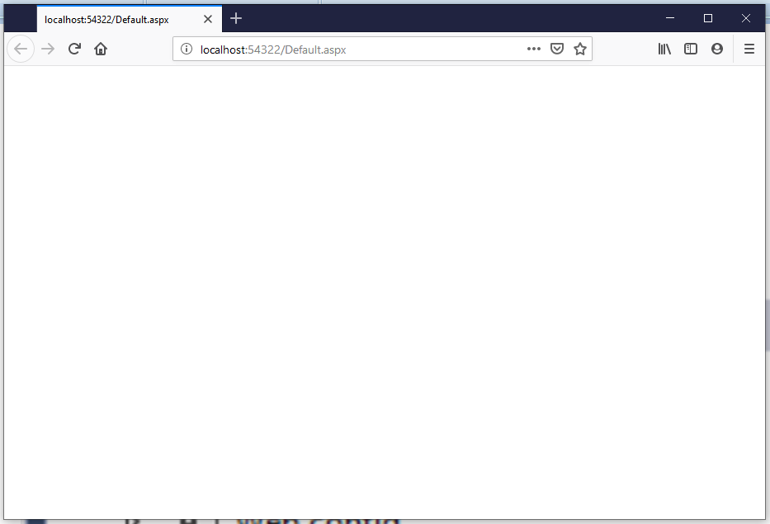
Not much to look at but we know that all is working OK.

Creating the Controls
A Web Form is an HTML page designed in such a way that we may design the layout of the page using the visual designer and add code the page.
We will modify the default page with controls like so…
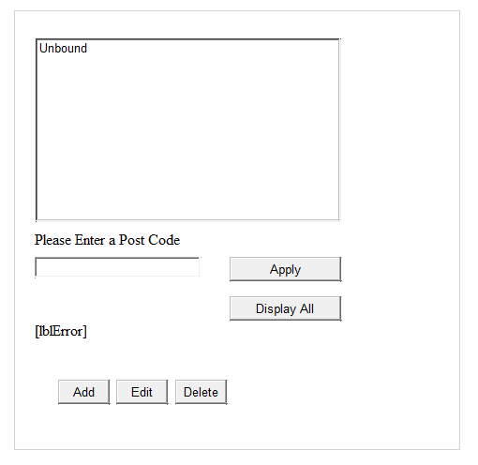
Double click the web page and notice also that the designer defaults to the HTML view for the web page...
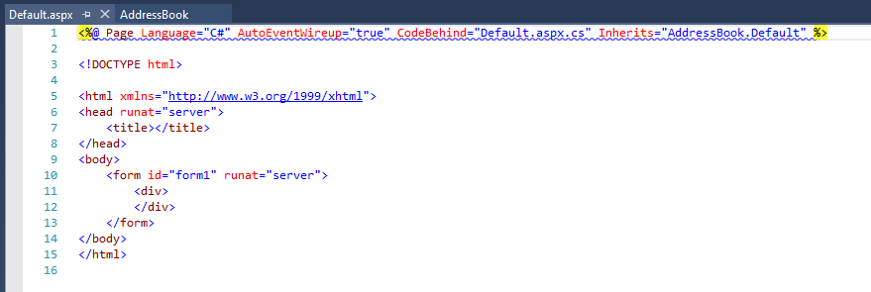

At the moment, this may look a little intimidating. If you are a lover of writing HTML, you could do this here. However, remember the module is called VISUAL Web Development!
You should see a button at the bottom of the screen that says “Design”.
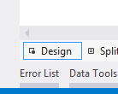
If you click this button you will be able to see the default web form in visual design mode…
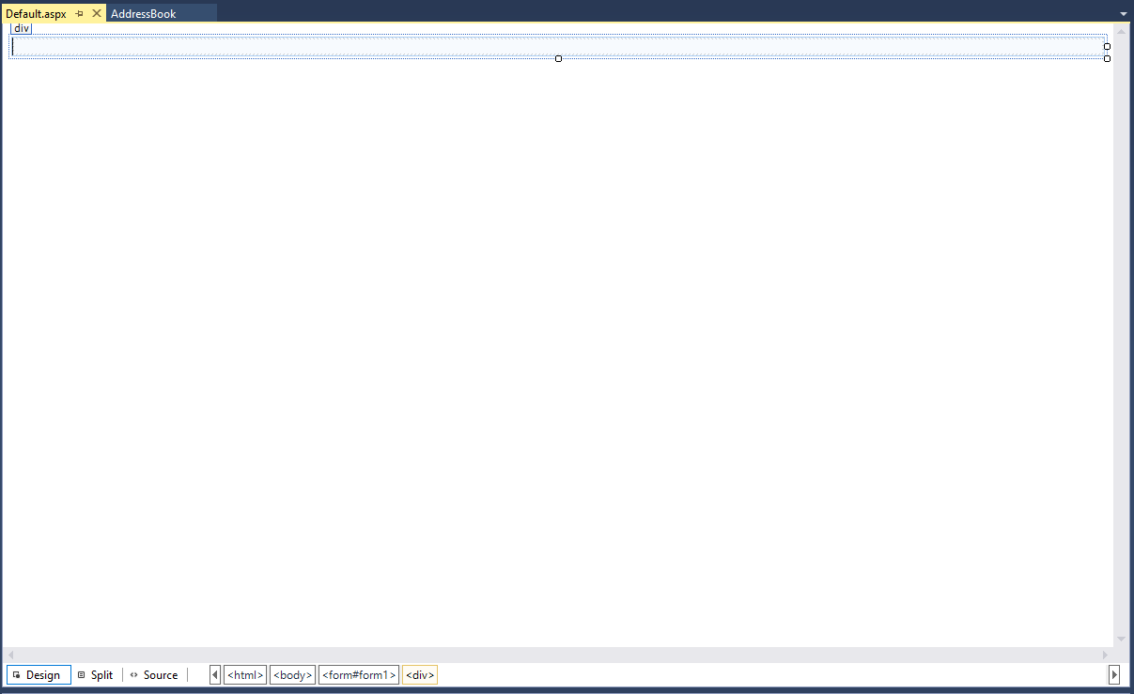

Modifying the Form

Click once on the middle of the page to select the document part of the page.

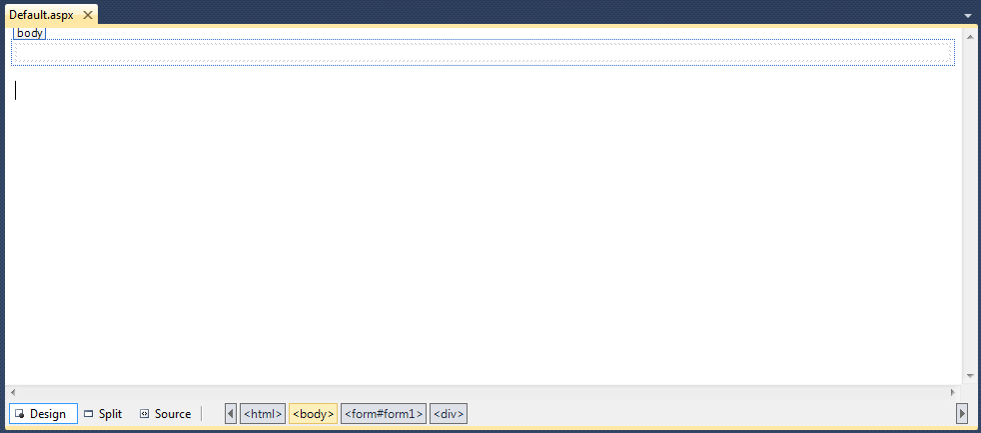
The properties window at the bottom right hand corner of the screen allows you to change the look and behaviour of the various parts of our program.
In the properties window locate the property called Title and replace it with Address Book. (This is the text at the top of the form so don’t worry about camel case as this is there for the user of the page.)
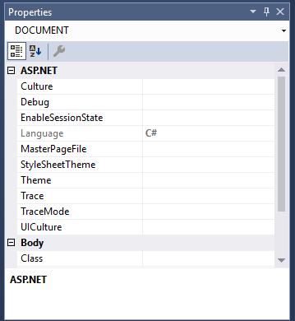

Running the Program
Although you haven’t really done very much yet, have a go at running the program so that you get some idea of where things are going.
To run your project press F5 on the keyboard or click the start debugging button on the toolbar.
You may get the following message the very first time you run the program…
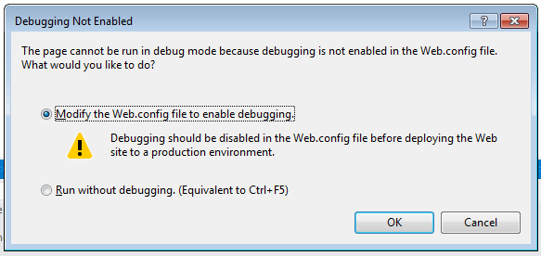
Debugging is the process of finding errors in our code when things go wrong.
Yes, we do want to enable debugging so make sure that the modify option is selected and press OK.
Eventually the browser will run displaying a blank page – not very exciting I know!
Not really very useful either as the program lacks any Control Objects so that you can do something.
Close the form by quitting the broswer.
(with some browsers you may need to press the stop button in Visual Studio too 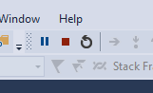)
The next step is to add some controls so that it does something useful.

Adding Control Objects to a Form
Control Objects allow the user to perform actions such as view / modify data in your application.
There are many controls available in ASP.NET. You will have already seen many of them when you use the Web.
For example, if you look at the sample applications you will see the kind of interface we are going to create.
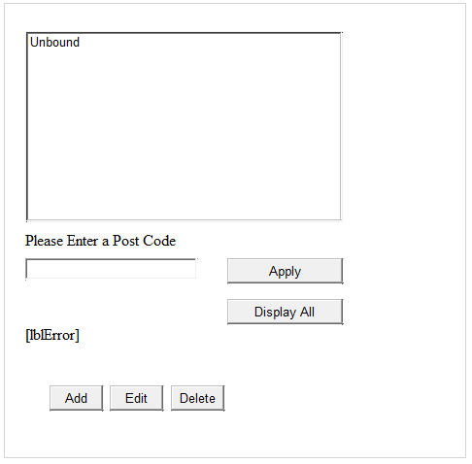
Text box
Label
List Box
Button
Before we draw any controls, we need to make sure that positioning is set so that we can draw them wherever we like.
Select tools and options
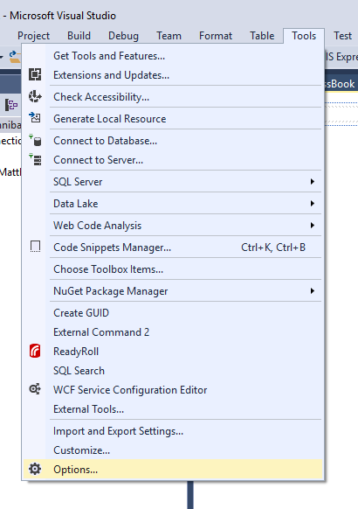
And locate “CSS styling” under Web Forms designer
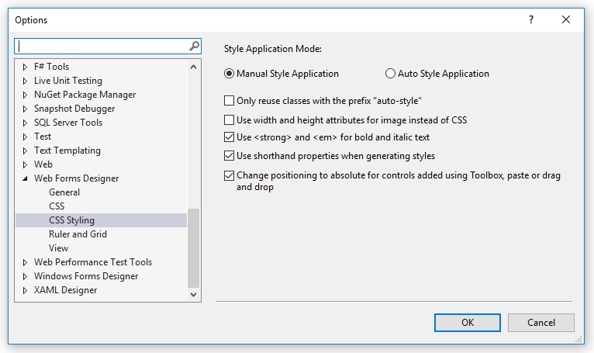
Make sure that there is a tick in this tick box
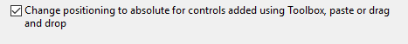
Having done this you may want to look at this link to find out why this is a really bad idea, but since you are learning how to do all this we will do it anyway!
https://stackoverflow.com/questions/1505231/what-is-the-problem-with-visual-studio-nets-absolute-positioning-and-how-is
This will allow you to draw your controls wherever you like. When you have done this, press OK.
We may now draw some controls on our page. Controls are located at the left of screen in Visual Studio in the toolbox.
Locate the Toolbox icon on the left of the screen…
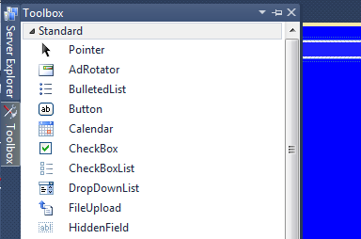

The four we are interested in on the first page are…
The Text Box
The Button
The Label
The List Box
You may double click on these controls in turn to add them to your form, or you can drag and drop them onto the form.
The next step is to position the controls and set the properties for them.
Using the mouse, drag each control around the form until they are set as follows.
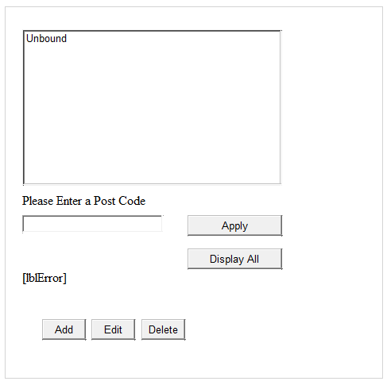

Setting the Properties for Controls
We now need to set some properties for the controls.
To set the properties, click on one of the controls and the properties are displayed in the properties window at the bottom right of the screen.
Click once on the label for the text box and then set the following properties…
ID to lblPostCode
Text to Please Enter a Post Code

Click once on the Text Box and set...
ID to txtPostCode

Set up the rest of the controls like so...
ID - btnDelete
Text – Delete
ID - btnEdit
Text – Edit
ID - btnAdd
Text – Add
ID - btnDisplayAll
Text – Display All
ID - btnApply
Text - Apply
ID - lstAddresses

ID - lblError
Text – {blank}

Notice how you used camel case in the above examples.
e.g. btnEdit NOT btnedit

Also notice that you typically set two properties.

Text - Which is the text displayed to the user. It is better that buttons say things such as “Go” on them rather than “Button”!

ID - The ID is the name given to the specific control so that when it comes to writing code we know which control we are referring to.

Notice that there is a specified format for the ID.
The three-letter prefix,
btn for Buttons
txt for Text Boxes
lbl for Labels
lst for List Boxes

Then a suffix that tells us about the control.
This is called a naming convention and helps to make our lives easier as programmers. The computer doesn’t care what naming convention we use or even if we use one at all!

Adding a Second Form for Delete
Before we add any code to the application we shall add a second page for the delete functionality.
Add a new web form as above but this time change the name of the page to Delete.aspx...
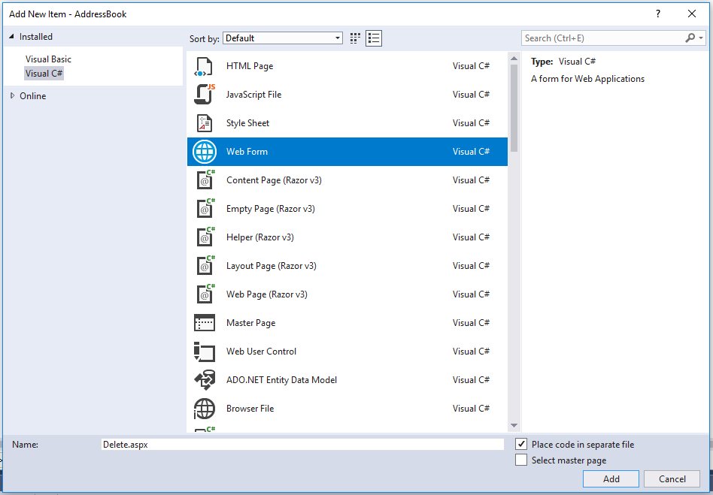

Set up the page like so...
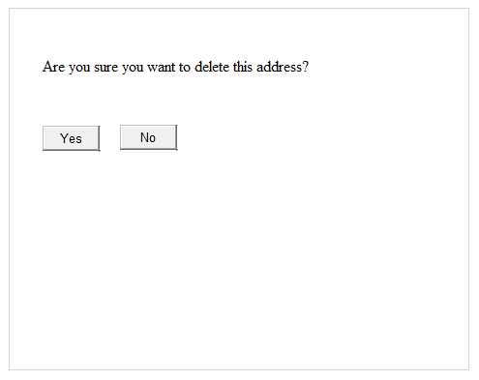
Make sure you select suitable names for your controls.
Once done you should have two web pages in your presentation layer like so...
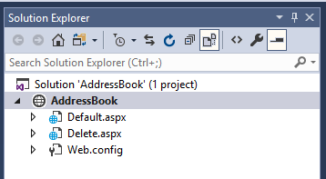

What we are going to do now is add some code allowing us to navigate between the pages.

Adding Code – Event Driven Programming
Web Forms use an event driven model. This means that when an event happens to the form or a control on the form a function is triggered to process that event.
One common event is called the click event and the code that handles the event is called the click event handler.
From the page Default.aspx
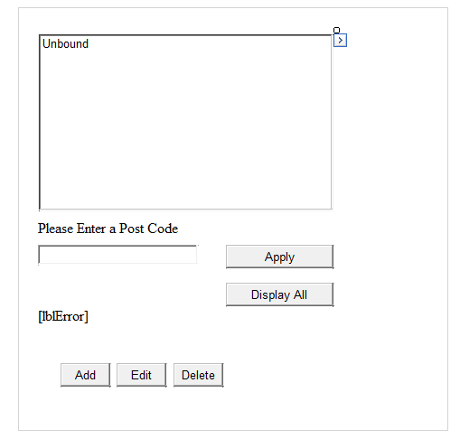
Double click on the delete button, doing this will allow you to enter some code into the function for that button so that it does something when it is clicked.
You should see the following...

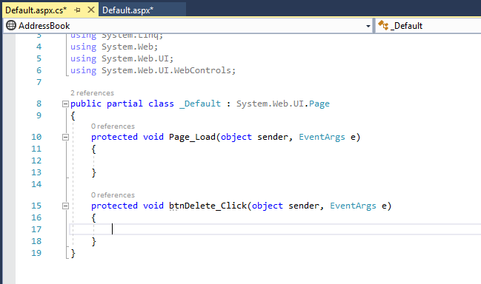

This is where the code that drives the interface for this web form will go. Much of the structure is generated automatically so it is best not to change this at all.
The cursor will land at the place where your code needs to go...

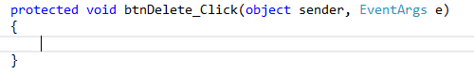

DO NOT DELETE ANY OF THE DEFAULT CODE CREATED FOR YOU!

Modify the code as follows...
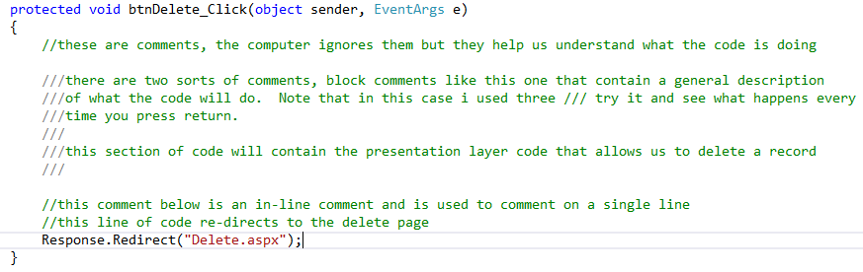

We have done two things here.
1. We have added comments to our code to help us understand what the code is doing
2. We have added a line of code that redirects us to the delete page
Notice also that the single line of code ends with a semi colon
One thing to keep in mind at this point when writing your code is this...

“Don’t forget the semi colon!”

To run your project press F5 on the keyboard or click the start debugging button on the toolbar.
What should happen is the browser will open and display the main page Default.aspx

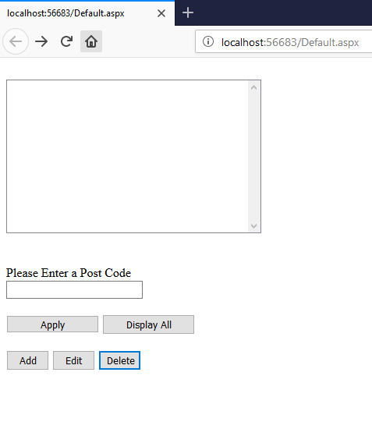

If you press the button Delete the buttons click event handler is triggered and the page should re-direct to the page Delete.aspx...
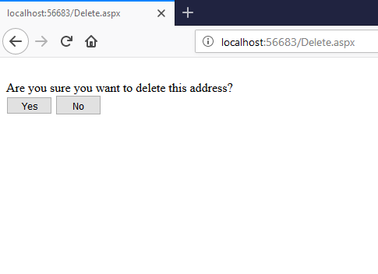
Add suitable re-directs to the buttons on the delete page so that when clicked they navigate back to Default.aspx.
Tip
The lines of code you need to add are these...

//this line of code re-directs back to the main page
Response.Redirect("Default.aspx");

